Subnetting exercises
- How many host addresses are available in the following networks?
IP | Subnet mask in dotted decimal | Network bits | Host bits | # available hosts in the network
151.238.65.128/25
138.246.224.0/20
218.85.109.16/29
221.123.100.0/27
28.49.0.0/.. | 255.255.252.0
216.165.176.64/.. | 255.255.255.192
222.118.173.0/.. | 255.255.240.0
172.86.156.0/.. | 255.255.248.0

- Fill in the table using the given IP address
IP | Network  Address | Broadcast  Address | First Host Address | Last Host Address | # available hosts
197.53.96.135/28
182.48.180.135/24
1.54.237.129/21
12.210.139.230/25
111.172.197.153/17
194.99.221.165/27
72.1.7.47/22

- A router is configured with the IP address 114.135.225.17/28. Which of the following IP addresses can I use to assign to a host in that network?
IP | Network  Address | Broadcast  Address | First Host Address | Last Host Address

- 114.135.225.17
- 114.135.225.16
- 114.135.225.18
- 114.135.225.0
- 114.135.225.1
- 114.135.225.31
- 114.135.225.30
- 114.135.225.32
- 114.135.225.64
- 114.135.225.65
- 114.135.225.254

- Subnet the following network based on the number of needed networks using the network address: 173.231.70.128/25 and address all devices
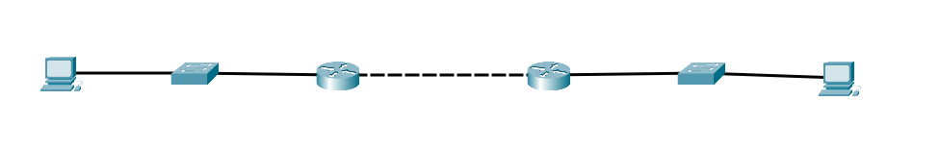

Number of needed networks:
Number of additional network bits:
Total number of networks:
Number of unused networks:
New subnet mask:
Network | Network Address | First Host | Last Host | Broadcast

- Subnet the following network based on the number of needed networks using the network address: 199.202.128.0/17 and address all devices
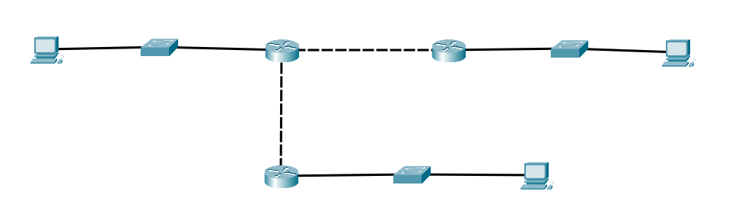

Starting network address:
Number of needed networks:
Number of additional network bits:
Total number of networks:
Number of unused networks:
New subnet mask:
Number of hosts per network:

Network | Network Address | First Host | Last Host | Broadcast

- Subnet the following network based on the maximum number of needed hosts using the network address: 137.65.208.0/20 and address all devices
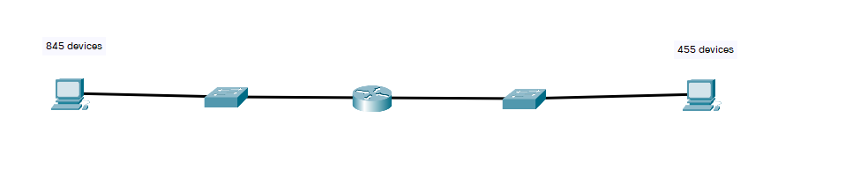

Maximum number of hosts on a network:
Number of needed host bits:
Total number of networks:
New subnet mask:
Number of hosts per network:
Network | Network Address | First Host | Last Host | Broadcast

